DESIGN ANDIMPLEMENTATION OF STAFF BIOMETRIC ATTENTANCE
A CASE STUDY OF GOMBE STATE POLYTECHNIC BAJOGA
BY

NAMES | REG.NO
YAHAYAT M ASABE | ND/CS/20/0799
BASHIR HAMAGAM | ND/CS/20/0611
UMAR IBRAHIM | ND/CS/20/0703
AHMAD ABDULLAHI | ND/CS/20/0758
UMAR ALIYU | ND/CS/20/0814
A PROJECT SUBMITTED TO THE DEPARTMENT OF COMPUTER SCIENCE, SCHOOL OF SCIENCE AND TECHNOLOGY, GOMBE STATE POLYTECHNIC BAJOGA IN PARTIAL FULFILMENT OF THE REQUIREMENT FOR THE AWARD OF NATIONAL DIPLOMA (ND) IN COMPUTER SCIENCE

JAN, 2023

DECLARATION
We hereby declare that this work is the product of our research effort, under taken under the supervision of Mal. Ibrahim Hassan and has not been presented and will not be presented elsewhere for the award of ND certificate. All sources have been duly acknowledged.

CERTIFICATION
This is to certify that the project titled “Staff Biometric Attendance” was carried out under the supervision of:-

………………………………… ………………………….………
MAL IBRAHIM HASSAN DATE
PROJECT SUPERVISOR

………………………………… ………………………….………
Mr. Isma’il Adamu Abdulkarim DATE
Head of Computer Scienece

………………………………… ………………………….………
EXTERNAL EXAMINER DATE

ACKNOWLEDGMENT
Our profound gratitude goes to Almighty Allah the creator of the universe. This work is a synergistic product of many minds and we feel a deep sense of gratitude to our parents, brothers and sisters, our friends for their encouragement and for being ever supportive. Our sincere thanks goes to our supervisor Mal Ibrahim Hassan for his thorough assistance with this work.
We appreciate the effort and care of the Head of Computer Science Department Mr. Ismail Adamu AbdulKareem.

DEDICATION
We dedicated this work to our beloved parents, brothers and sisters for their support toward the completion of our academic activities.

ABSTRACT
Biometrics is one of the greatest widely used approaches of evaluating attendance of staff. The use of Biometrics in administering attendance can improve efficiency and avoid cheating. A staff biometric attendance was designed and implemented to reduce the loss of staff record. The staff biometric attendance was developed using the Waterfall Model of a Software Development Life Cycle (SDLC). Implementation was done using open source web-based technologies such as XAMP server, MySQL, PHP, JavaScript, Cascading Style Sheet and Hypertext Markup Language. The staff biometric attendance presents the record of the staff. The use of staff biometric attendance can improve the efficiency and profitability of academic institutions as it reduces the cost of
Stationeries and labour involved in avoiding manually records.

Table of Contents
Cover Page--------------------------------------------------------------
Declaration-------------------------------------------------------------- ii
Certification------------------------------------------------------- iii
Acknowledgement---------------------------------------------- iv
Dedication--------------------------------------------------------v
Table of Contents ........................................................... vi
List of Tables .................................................................. vii
List of Figures ................................................................... viii
Abstract--------------------------------------------------------------- ix
Introduction
Literature Review
System Analyse and Design
System Implementation and Testing
Summary, Conclusion, and Recommendation

CHAPTER ONE
INTRODUCTION
1.1 Background to the Study
Punctuality as Thomas Chandler Haliburton (1796 – 1865) said, is the soul of business. Any institution will require its staff to be punctual for it to be a success. Punctuality as a function of time with respect to date is a very essential requirement in every setup, be it small scale or large organization/institution, of which Gombe state polytechnic bajoga is not an exception (Shoewu, 2019).
The level of impersonation as well as the ghost worker syndrome in recent times is enormous, in both the private and the public sector, Akinduyite, Adetunmbi, Olabode, and Ibidunmoye (2016). Therefore, there is need for a new system which will wipe out all this enumerated issues. The human body has the privilege of having features that are unique and exclusive to each individual. This exclusiveness and unique characteristic has led to the field of biometrics and its application in ensuring security in various fields (Wati et’al, 2019). Biometrics has gained popularity and has proved itself to be a reliable mode of ensuring privacy, maintaining security and identifying individuals. Today, the technology is being spotlighted as the authentication method because of the need for reliable security (Arulogun et al, 2016).
A system insusceptible to impersonation, that provide dependable and efficient means of taking staff attendance record with the use of biometrics captures to provide perpetrators with the uniqueness of biometrics will help organization/institution keep good and accurate record of their staff punctuality. Punctuality is one of the most important attribute of a good professional, this project is motivated by the desire to bring and enhance professionalism in organizations and institutions (Kennedy, 2017).
The trending concern in this modern world is regarding national security, identifying theft as well as on-line terrorism. Researcher refers to Biometric as a solution for detecting user’s identity and security challenges emanating in this modern day. Biometric identification is any automatically measurable, robust and distinctive physical characteristic or personal trait that can be used to identify an individual or verify the claimed identify of an individual (Seifedine, 2016). Biometric science utilizes the measurements of a person’s behavioural characteristics (keyboard strokes, mouse movement) or biological characteristics (fingerprint, iris, nose, eyes, jaw, voice pattern, etc). It is the features captures that is being transformed digitally into a template (Shoewu, 2020). The recognition software can then be used to discover an individual as the person they claim to be. Fingerprint recognition is the most common biometric method adopted in identification of a person (Ismail 2019).
Biometric is a field of technology that uses automated methods for identifying and verifying a person based on physiological and behavioural traits (Idowu, 2021). Because some parts of the human body is use in biometrics, the issue of getting lost is not possible and for password to be easily guess can be easily avoided. Also, utilizing biometrics in most cases can be said to be more efficient when speed is considered and convenient than employing password and ID cards method.
Using a particular person fingerprint as a form of authentication is just like using natural physical data as a password. The benefit of using biometric authentication is that it is absolutely distinct to each person (Muhammad, 2017). There are no two different individuals with the same fingerprint, it is difficult and impossible for one another to have the same fingerprint, and fingerprints from different people can never be the same (Olatunji, 2017). Also, a fingerprint can never be guess by a criminal, such as a password which imposter can easily predict using a user birth date or any other common password. Infiltration is very hard to come by due to the fact that criminal will not be able to snoop around to steal user password when using ATM with the 4-digit pass code (Valasquez 2016).
Fingerprint can be categorize as one of the most mature biometric traits and is accepted in courts of law as a legitimate proof of evidence (Rahman, 2021). Fingerprints are adopted in forensic analysis globally in investigations of criminal. More recently, there are growing numbers of individuals and commercial users that are currently using or strongly putting into consideration of using fingerprint-based identification for no any other reason other than the matching performance biometric technology has demonstrated as well as a better understanding of fingerprints (Olatunji, 2017).
Although, there are so many positive impacts for using biometric authentication, however, unlike username and password, biometric data is a physical feature of a person that is fixed and cannot be change (Norshidah, 2015). If a person could have access to adequate scan another person fingerprint, that scan has the capability to trick the Touch ID system. In that case, the fingerprint features of a person can’t be change consequently a criminal can’t be prevented from having access to your personal information or files (Helmy and Rasyid, 2016). As fingerprint scanning becomes more widely accepted anywhere anytime, this may become a substantial challenge. A criminal can have access to different accounts because with one fingerprint, a criminal may have access to multiple accounts that implemented authentication using fingerprint.
1.2 Statement of Problem
Traditionally, staff attendance is done by signing in and out in a register which leaves gap for impersonation and staff sometimes record earlier time when they are late (Kama, 2018). Fingerprint is a unique feature for everyone compare to using barcode in smart cards. Therefore, this system designed staff Biometric attendance system for Gombe state polytechnic bajoga in this project work is not based on the existing barcode system. Tracking and monitoring staff time of attendance could be tedious, time consuming and more susceptible to errors. The security of the existing attendance system that are now use in developing a staff attendance of Gombe state university can be easily compromised. Some staff can master other staff signature. Thereby, helping their colleague who are absent for a particular class to sign the attendance sheet using the duplicated signature. The Fingerprint Attendance monitoring system designed in this research work for Gombe state polytechnic bajoga staff is a more secure platform where the staff can mark their attendance with their fingerprint.
The efficiency of the scanner can be reduced due to the roughages in the captured images which are often caused by worn-out or cut or dirt’s found on fingerprint (Olagunju, 2018). Therefore, there is every possibility that enrolled users can be rejected by the system. Also the scanner or sensor cannot distinguish between a real and an artificial finger; therefore, it is possible to fool the scanner. In addition, if an enrolled fingerprint is been duplicated or spoof, it is not possible to change fingerprint as in the case of password because user finger biometric.
1.3 Aim and Objectives of Study
This project is aimed at developing a staff Biometric attendance system for Gombe state polytechnic bajoga.
The objective of these project are to:
- Design staff attendance system using fingerprint biometric.
- To generate a report
- Test the implemented Staff attendance using android application in gombe state polytechnic bajoga

1.4 Scope of the Study
The scope of this work is to develop a developing a staff Biometric attendance system for Gombe state polytechnic bajoga that will improve how attendance management is done by using fingerprint as a form of authentication for proof of attending office. The system will be a mobile based application developed using android OS as the preferred programming language for building the user interface
1.5 Limitation of the study
This project is limited to staff of Gombe state polytechnic bajoga, the fact that the proposed system doesn’t have a centralized database, which means staff enrolment will have to be done at their work unit. Furthermore, transferred staff details will be copied to the new unit database or re-enrol at new station before the staff can have access to the system.
1.6 Significance of Study
The use of staff attendance system is very important because of human being proneness to error, leaving the staff to write down their names might not be accurate as staff can even write attendance for their fellow staff and their handwriting legibility can be a case when compiling the attendance record at the end of the month.
The official in charge of attendance collation is highly favoured by this system because use of pen and paper as a means of collating staff attendance will leave the official in charge with numerous sheet of paper, which will be hectic as he/she have to start comparing several sheet to record the average attendance for just a staff. The official is going to waste a lot of time compiling the attendance percentage at the end of the month, mistake can creep in due to the large volumes of papers. Successful implementation of this project mean the staff attendance credibility can be queried or put to test anytime, and result are produce fast and accuracy, without stress.

1.7 Operational Definition of Terms
Biometrics: Biometrics is best described as a personal identity verification system, meaning that your personal identity is verified by using individual and unique physical characteristics such as your fingerprints, hand geometry, speech, eyes, handwriting, or facial recognition (John M., 2014).
PIN: A personal identification number (PIN) is a numerical code used in many electronic financial transactions. Personal identification numbers are usually issued in association with payment cards and may be required to complete a transaction (Julia and Khadijah, 2020).
Biometric Verification: Biometric verification is any means by which a person can be uniquely identified by evaluating one or more distinguishing biological traits (Khermerl, 2022)
Scanner: a device for examining, reading, or monitoring something in particular (Katie, 2018)
Fingerprint sensor: is an electronic device used to capture a digital image of the fingerprint pattern (Munish and Priyanka, 2018)
Rapid Application Development: Rapid Application Development or RAD means an adaptive software development model based on prototyping and quick feedback with less emphasis on specific planning (Muhammad, 2022)
Authentication: is the process of determining whether someone or something is, in fact, who or what it declared to be (Arun & Anil, 2019).

CHAPTER TWO
LITERATURE REVIEW
2.0 Introduction
This chapter is on the documented efforts and works both published and unpublished, made by scholars on the subject matter.
2.1 Conceptual Framework
2.1.1 What is Biometrics?
Biometrics is the science and technology of measuring and breaking down natural information. In data innovation, biometrics relates to technologies that examine and measure physical human body features, such as DNA, fingerprints, eye retinas and irises, voice patterns, facial patterns and hand measurements, for validation or authentication purposes (Rouse, 2018).
In Computer Science, biometric identification or biometric authentication is utilized as a mode of identification and access control and also being implemented to detect individuals in groups that are being watch or under surveillance (Jain, Anil K, Ross, Arun , 2008). Using biometric verification is turning into a progressively regular for Authentication in corporate and public security systems, consumer electronics and point of sale (POS) applications. In addition to security, the motivation behind biometric verification has been convenience to avert identity theft, biometric data is usually encrypted when it's gathered (Wayman, 2015).
2.2 Types of Biometric Devices Available
There are several types of biometric data use commonly today. Each of these devices has a different mechanism employed to captures data in different form.
The different types of biometric that are frequently in use today are devices that capture data in various formats using different mechanism. The method of production and trait of the biometric data indicates the encroaching of the protocol for enrollment and authentication of users (Woodward, Nicholas 2003).
2.2.1 Retina Scanner
These scan are the distinct biometric feature/pattern in each individual’s iris, and compares it with a certain number of distinct recognizing patterns which distinguish each individual separately from other people (Kumbhar & Wanjara, 2014). In a retinal scan, at the back of the eye, a biometric format is shaped by recording the patterns of capillary blood vessels. Iris scanning can be carried out remotely utilizing a high-resolution camera and formats generated by a technique similar to that of retinal scanning.Iris scanning and retinal scanning are both used to distinguish a person as indicated by their distinct pattern (Trivedi, 2019)
2.2.2 Iris Scanner
Iris scanning is an automated method of biometric identification which uses mathematical pattern-recognition techniques on video images of the iris of a person’s eyes, whose complex random patterns are distinct and be spotted from a far range (Shoewu, Olaniyi, and Lawson, 2011). Digital formats which are referred to as template are converted from these patterns by using mathematical and statistical algorithms which allow the identification of an individual or someone trying to impersonate the legitimate person. The significant benefit of iris recognition, apart from its utmost resistance to false matches and speed, is the stability of the iris as an internal, protected, yet externally visible organ of the eye.
Figure2.1 Structure of Iris

The major feature that depicts iris of the eye as the most ideal and accurate section of human body for biometric recognition is that it is an internal organ which is better guided from damage and wear by extremely sensitive and transparent membrane (cornea). This characteristic makes it more better option to fingerprint, which can be difficult after years of rigorous involvement in some manual labor (Cheng and Ushijimaa, 2015).
The iris is mostly flat, and its geometric configuration is only controlled by two complementary muscles (the sphincter pupillae and dilator pupillae) that control the diameter of the pupil. This makes the iris shape far more predictable than, for instance, that of the face. The iris has a fine texture that like fingerprints is determined randomly during embryonic gestation. Like the fingerprint, it is very hard (if not impossible) to prove that the iris is unique (Christine, Modi, 2018).
2.2.3 Fingerprint Scanner
When considering the price of biometric identification scanners available in the market today, fingerprint scanning is always on the lower end. There are some fingerprint scanners that can only scan the actual print while the costlier scanners can capture the shape and size of the thumb, presence of blood in the fingerprint and other physical characteristics on a finger (Smaili, 2013). The expensive scanner can capture a 3D image of the fingerprint which in turn makes it more difficult for such fingerprint to be duplicated. The process of acquiring image by the scanner is either though capacitance sensing or optical scanning.
The three fundamental patterns of fingerprint ridges are presented below.
- Arch: In arch, the ridges will enter from one side of the finger then rise in the centre forming an arc, and then exit the other side of the finger.
- Loop: The ridges enter from one side of a finger, form a curve, and then exit on that same side.
- Whorl: Ridges form circularly around a central point on the finger.
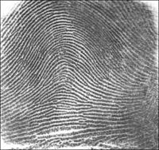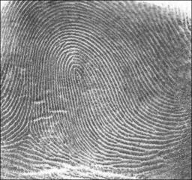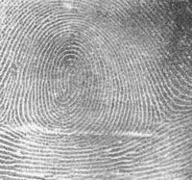
The arch pattern the loop pattern the whorl pattern
Figure2.3 Fingerprint patterns

Minutia features
The major minutia features of fingerprint ridges are ridge ending, bifurcation, and short ridge (or dot). The ridge ending refer to the point at which a ridge terminates. Bifurcations are points whereby a single ridge is divided into two ridges. Short ridges are ridges which are importantly shorter than the average ridge length on the fingerprint. Minutiae and patterns are very important in the examining of fingerprints since there has not been any record of two fingerprints proven to be identical.
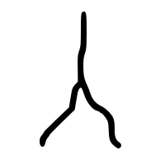
The ridge ending Bifurcation Short ridge (dot)
Fingerprint sensors
A fingerprint sensor is an electronic device used to capture a digital image of the fingerprint pattern. The image captured from the sensor is referred to as a live scan, which in turn is processed digitally to develop an accumulation of extracted features (Biometric Template). This template is stored in a database and utilized for matching. Figure 2.4 presented some fingerprint sensors.
Figure2.4 Scanners

2.2.4 Facial Biometrics
The image or video of an individual is generally views by the facial biometrics devices and then compares it to the template stored in database (Khairatkar & Sharma, 2014). when matching is being carried out by the facial biometrics, it compares the ratio, shape and structure of the face, the interval between the jaw, top outlines of the eye sockets, the sides of the mouth, eyes, mouth, nose, the region of the cheek bones and the positioning of the nose and eyes (Idowu, 2012). When a user is being enrol in a facial recognition program, various images are captured of the individual at different positions and angles with various facial expressions. In the process of verification and identification the individual will maintain a position facing the camera some seconds, after then the image is verified against the template stored (Shoewu, 2013). In other to prevent an individual from putting on a picture or mask when being scanned, some security criteria have been put into place (Shermin and Mouri, 2021). The user may be asked to smile, nod their hand or blink their eyes during the scanning process. Also as part of the security criteria would be to use facial thermograph to store the heat in the face.
2.2.5 Voice Recognition
Every individual on the soil of the earth has a distinct voice pattern. Although the changes can be hardly noticeable to the human hear because it’s a slight change (Asma and Enayet, 2019). Nevertheless, with the aid of exceptional software for voice recognition, those minute variations in each individual’s speech can be spotted, tested, and authenticated to give access only to the person owns the tone, pitch, and volume of speech uttered (Asyraf and Saiful, 2018). Voiceprint recognition performs its operation by comparing the vocal patterns of an individual with template previously stored. This type of biometric has the ability to determine duress through adequate examining of pattern of stress in the input voiceprint (Mohamad 2018). This feature gives voice recognition an advantage over other forms.
2.2.6 Hand Print Patterns
Similarly to finger print, everybody has distinct handprints. A handprint Biometric Systems scans hand and finger and the captured feature is compared with the specimen stored for the user in the system (Noma-Osaghae and Olatunji, 2017). The user is given access or rejected based on the result of this verification. Handwriting recognition is the ability of a computer to receive and interpret intelligible handwritten input from sources such as paper documents, photographs, touch-screens and other devices (Etinosa, 2016). The image of the written text may be sensed "off line" from a piece of paper by optical scanning (optical character recognition) or intelligent word recognition.
When a person’s hand is place on a scanner, such user will have a distinct fingerprint pattern, as well as the size and shape of the entire hand is also very unique (Etinosa, 2017). This is a more complex approach compare to regular fingerprint scanning, and will definitely be more accurate with minimum occurrence of falsification (Kennedy, 2013). Templates generated can be said to be very compact, and the method is often sensed by users to be less invasive than other types of biometric devices.
Attendance Management has also been carried out using attendance software that uses passwords for authentication. The authors in designed and implemented a system that authenticates the user based on passwords, this type of system allows for impersonation since the password can be easily fiddled (Michael and Indico, 2014).
Another related study to this personal authentication system using fingerprint biometric is the Biometric Voting Machine where voters are been registered and vote using the fingerprint biometric (Talaviya, 2017). This machine makes staff answer present in a daily work in order to avoid cheating or imposter voting more than once (Gunjan, 2015). Technology is being used more and more as a tool to assist staff to answer present during the work hours. To allow the exercise of this right, almost all voting systems around the world includes voter identification and authentication, voting and recording of votes cast, vote counting, publication of election results and these are achieved using the Biometric Authentication system using fingerprint. Voter identification is required during two phases of the electoral process: first for voter registration in order to establish the right to vote and afterwards, at voting time, to allow a citizen to exercise their right to vote by verifying if the person satisfies all the requirements needed to vote (authentication).
Another important reason fingerprint scanners are used is, they provide a quick, easy, efficient, and secure measure through which, an individual with the proper access privileges can authenticate (Segen and Kumar, 1999). The fingerprint of an employee for example, is stored in a database that the scanner queries every time it is used. There are two basic Boolean conditions the scanner then goes through when an individual’s print is scanned.
CHAPTER THREE
SYSTEM ANALYSIS AND DESIGN
3.1 Preliminary study
The study reviewed relevant empirical studies as related to the topic under study, the study was carried out in line with the following sub-headings; Preliminary study, Problems definition, Objectives, Significance, Feasibility study, Technical feasibility, Operational feasibility, Economic feasibility, System analyses and System Design
3.2.1 Problems definition
For manual attendance signing process, the most common problem is the lecturer need to take staff daily attendance and manually filled the record in attendance sheet or book for daily attendance. If the attendance sheet is missing or misplaced, it could lead to big problem because the lecturer need the attendance record to make analysis and generate an attendance report. Another problem is the lecturer will need more time to analyze and generate the attendance report because the lecturer needs to search and refer the old attendance record first. Besides that, an error could happen when the teacher make the calculations to generate the attendance report by themselves. Even though the attendance record is hassle to keep by the lecturer, management report is required in urgent basis. Analysed attendance record is required by the school management for future actions is normally being delay because of the lack of precise. Moreover, delay analyses would leads to prolong the time to inform the parents about the truancy students.
3.2.2 Objectives
Due to the importance attached to collection of accurate information from the right, authentic and reliable source. It is embarked on the mode of carrying out activities and project implementation in the university system. This methodwas adopted for the following reasons.
I- To have a first-hand knowledge about the number of hours a staff spent in the office.
Ii- To have a first-hand knowledge also on the staff to be rewarded for over time.
iii.To allow organization see the whole detail needed for the new system and its structure and how secured the system can operate in handling the activities of the attendance.
3.2.3 Significance
Attendance is an important aspect in office, regular attendance will not only ensure full exposure to the scope of majors and opportunities available at institution, and it is also one of the criteria used in determining your full attendance in the office. Tracking and monitoring staff time of attendance using the manual attendance in office be tedious, time consuming and more prone to errors. The manual attendance system that is use in offices (signature system) is not too secure because some staff can copy other staff signature.
3.3 Feasibility study
This report examines the feasibility of using biometrics as a means of establishing a unique identity, to support the proposed entitlement scheme. Biometrics identification systems measure physiological and behavioural characteristics of a person, and use these measurements to reliably distinguish one person from another.
3.3.1 Technical Feasibility
Feasibility study is the various activities involve in fact finding about the possibility implementing the new system and how the users of the environment feel.
3.3.2 Operational feasibility
The feasibility study aims at covering some aspect of the human problem which include
i. Business market
This simply involves the rate at which the system would be accepted in the organization and how flexible the system is to meet up with the number of user’s activity. In this business market, also the required resource that will cost to implement it in a larger database since the attendance biometrics system would capture staff attendance of Gombe state polytechnic bajoga.
ii. Target community to use this system
The target community is Gombe state bajoga academic staff and I surveyed the initial method being used and know that this new method is an improvement to the later method as result there would be good market value if this system is introduce to this Institution.
3.3.3 Economic Feasibility
The Economic Feasibility is to eliminate the use of paper in manual signing processes and all the risk associated with it and carry out the analysis of manual processes involved in officer attendance and examination attendance of staff with the aid of Fingerprint based staff attendance monitoring System.
3.4 System Analyses
This proposed system introduces a new automatic attendance management system, which integrates fingerprint authentication into the process of attendance management for both staff. It is made up of two processes namely; enrolment and authentication. During enrolment, the biometrics of the user is captured and the minutiae data are extracted and stored in a database as a template for the subject along with the user’s ID. The objective of the enrolment module is to admit a user using his/her and fingerprints into a database after feature extraction. These features form a template that is used to determine the identity of the user, formulating the process of authentication. The enrolment process is carried out by an administrator of the attendance management system. During authentication, the biometrics of the user is captured again and the extracted features are compared with the ones already existing in the database to determine a match. After a successful match, attendance is marked against the user’s id used in matching the templates.
The work utilized a fingerprint reader as the input to acquire images, developed program that has fingerprint recognition and identification system as well as database to store user’s information. The database comprises the fingerprint templates and other bio-data of the users together with the attendance records made by the users.
Figure 1 shows the architecture of the proposed attendance management system.
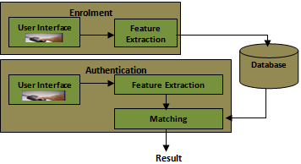

3.5 System Design
The block diagram of the biometric staff time and attendance logging system is shown in Fig. 2.
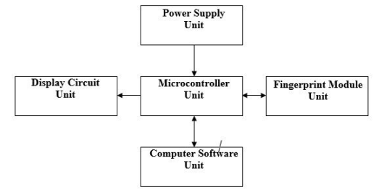
Figure 2: Block diagram of the biometric time and attendance logging system.
The Biometric time and attendance logging system consist of 5 major units namely;
- Power Supply Unit
- Microcontroller Unit
- Display Unit
- Fingerprint Module Unit
- Computer Software Unit

CHAPTER FOUR
SYSTEM IMPLEMENTATION AND TESTING

4.1 INTRODUCTION
Systems implementation is the process of putting the system design into action. Testing is conducted in order to evaluate the system’s compliance with its specified requirement.
HTML, CSS and Bootstrap are the languages used in developing the front-end of the system, MySQL is the database used to store all the records for easy retrieval, however PHP is the language used to consent interaction between the server and the system while the validity of the system were achieved using JavaScript and AJAX. System Testing involves the technique of executing a program using a test data with the diligence of detection and correcting imprecisions in the program. Unit testing is used in order to test this system. Unit testing is a software testing method by which individual units of source code—sets of one or more computer program modules together with associated control data, usage procedures, and operating procedures—are tested to determine whether they are fit for use. Wikipedia, 2022.
This section presents the implementation of the different modules of the Staff Attendance and the testing of these modules to ensure that they function in accordance with the Staff Attendance requirements.
The system front-end was heavily build using HTML and CSS while the back-end was build using PHP to interact the system with the data base. JavaScript was used to handle the prompting event in the system. Below are some pictures showing different interface in the system:

4.2 SYSTEM IMPLEMENTATION
This section grants the implementation of the different modules of the Staff Attendance System these modules to ensure that they function in accordance with the System requirement requirements.
The system front-end was heavily build using HTML and CSS and Bootstrap while the back-end was build using PHP to interact the system with the data base. JavaScript was used to handle the prompting event in the system. Below are some pictures showing different interface in the system:
i. Index Page
This is the page in the system where a staff can login using his Employee Id. A staff login to sign in when he came and he can also use his Employee ID to Sign out (Time in and Time out).

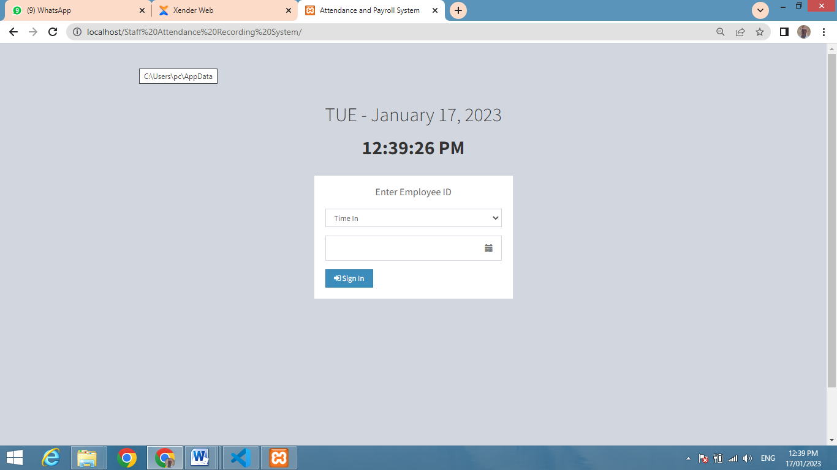
Figure 4.1: Index Page

ii. Admin Login Page

This is the page where the admin can input his credentials and have direct access to his dashboard. Often when admin input wrong credentials the system will not grant him access to his dashboard, rather, an error message will be displayed alerting danger on wrong credentials.
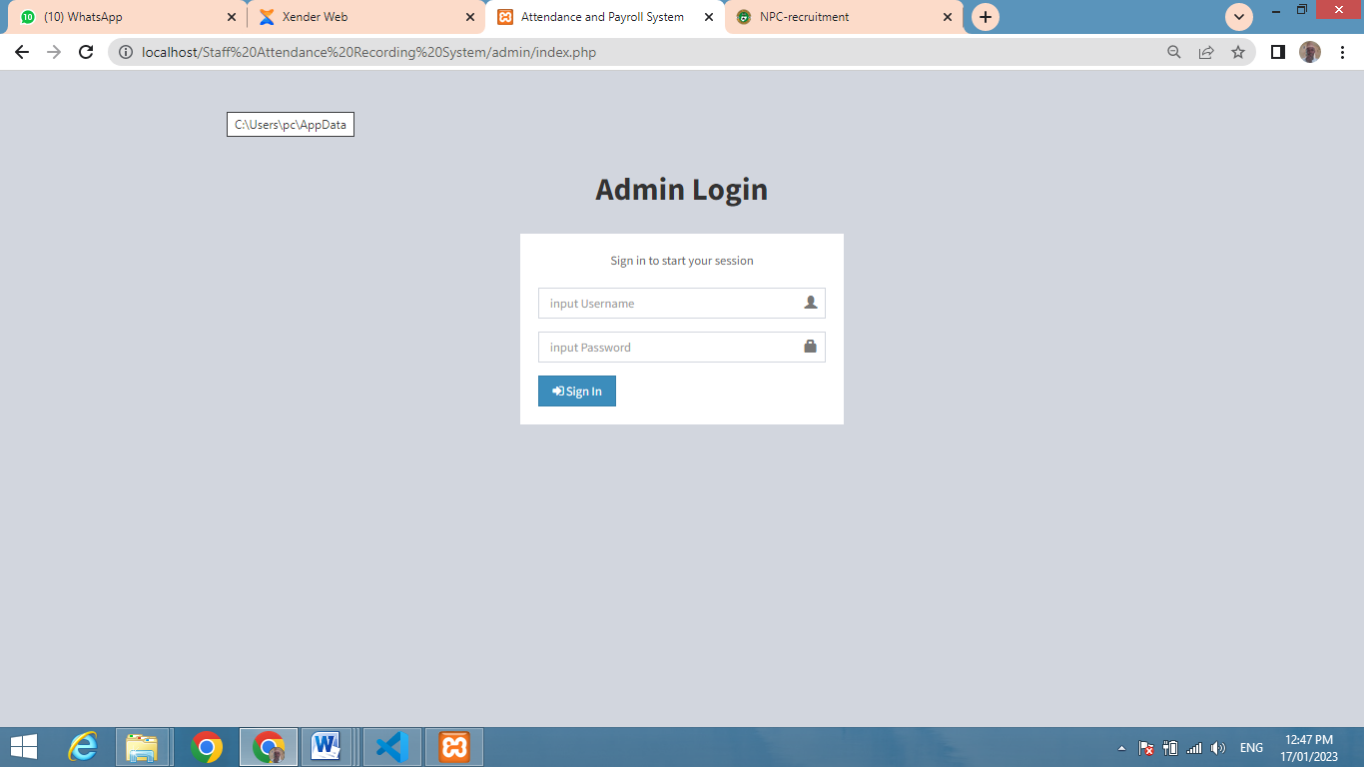

Figure 4.5: Admin Login page

iii. Admin Dashboard
The admin dashboard is page where admin can access and manage the activities of the system. In this page, the admin can add employee and manage, manage time in and out for the employees and the payroll of the employees.
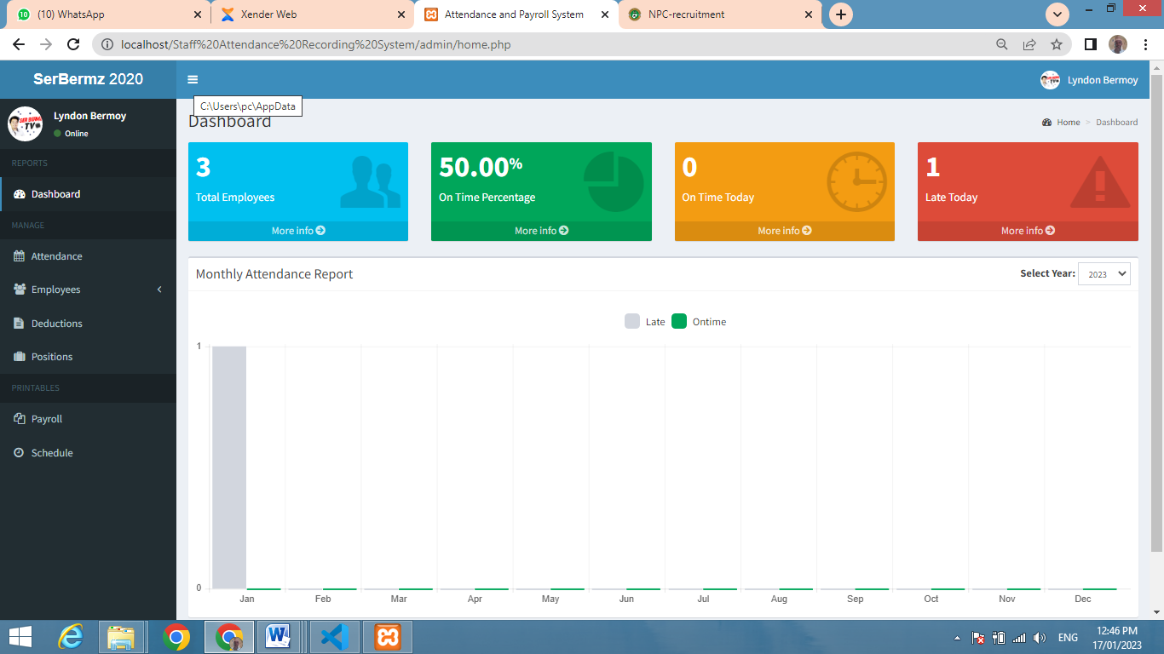

Figure 4.6: Admin Dashboard

4.3 SYSTEM TESTING
Unit and Integration Testing
Different modules (units), integrated system, including the system database were tested to ensure that the system is completely free from bugs. While unit testing embroils testing the individual mechanisms that make up the system, integration testing is primarily apprehensive with finding faults in the entire system. The database which is made up of a group of logically related tables was also tested to ensure that the set of rules and constraints guiding the type of data stored in the tables are not violated.

4.3.1 UNIT TEST FOR USER’S LOGIN PAGE
TEST | STEPS | EXPECTED RESULT | TEST RESULT
Authorized Admin Login | input username, password  click the login button | Show login successful | Display admin dashboard
Authorized Employee ID login | input Employee ID click the login button | Show login successful | Mark attendance
Display data | Automatically query  the data from the  server | Show data on the dashboard | Data shown on  the dashboard
Un-authorized Staff | input username, password  click the login button | Show incorrect login | Reload login page
Non-active user | input email, registration number  click the login button | Show incorrect login | Reload login page

4.3.2 INTEGRATED TESTING
Integration testing occasionally called integration and testing, abbreviated, is the segment in software testing in which individual software modules are combined and tested as a group. Integration testing is conducted to evaluate the compliance of a system or component with specified functional requirements. The followings are the basic module of the system:
1. Login Module
2. Dashboard Module
3. Employee Module
4. Attendance/Schedule Module
Integrated Testing table
Test Case Id | Test Case Objectives | Test Case Description | Expected Result
1. | Check the link between login page and dashboard module | After inputting credentials click login button | Get Directed to dashboard
2 | Check the link between employee approval request module | Verify Employee id | Sign the time in for work
3. | Check the link between employee approval request module | Verify Employee id | Sign the time out for work

CHAPTER FIVE

SUMMARY, CONCLUSION AND RECOMMENDATION

5.1 SUMMARY
The use of Staff Attendance Recording system forms the basis of the school management decision. It aims at providing the management with adequate, effective, well documented up-to-date and formatted output. To help as a tool in planning and decision making/based on the time in and time out of employees in an organization.
The lack of learner outcome variation of the web based system signals the establishment of concurrency between the two measures even though they are measures of same construct. This investigation supports the use the online system delivery structure to broaden the instruction audience in technology education program.
The use of online employee attendance system in technology education at the institutions remain at the minimal level as suggested by the 80% of the employee participants, predominantly technology education measures who report that they have not done online employee attendance system previously. Also 75%of online employee participant report that they have not used online employee attendance system previously. Having come to completion of this project work a lot of achievement was made and they include;
1. The replacement of error prone manual system with new automated web based employee attendance system
2. Data can now be processed with great speed and efficiency.
3. The application has the ability to update record in various files automatically there relieving the institutions staff the stress from working from file to file.
4. The security of data is ensured, the use of database server was implemented.
5.2 CONCLUSION
Research and growth are continuous processes; this is same in computer and software development. However the effectiveness and efficiency of this new system provide room for further improvement. As early mentioned some of the objectives of this project were not actualized due to some limitation. So this objectives could be improved upon, the outline employee attendance system developed will offer greater opportunity in school management.
5.3 RECOMMENDATION
The research work carried out is limited to online employee attendance system only. It would be better if a full portal is developed for effective and wholesome of information management technology in our institution.

